December 5, 2016
This Week at a Glance
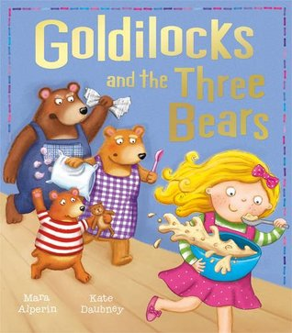
When Goldilocks sneaks into the three bears' cottage, no one seems to be home. But the bears soon return from their walk...Will they catch that naughty little girl?

Letter: G
Number: 5
Color: Green
Shape: Triangle

The Alpha Beats chant we recite when writing the letter G. “Up and around, back up, turn in, G.”
The Number Beats chant we recite when writing number 5. “Little line down, big hop around, across your five, number five.”
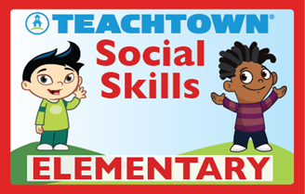
Theme: Be Nice When You Lose
The children are learning that it is important to be nice when they lose so that others will want to play with them.
Related Reading: Tess Tiger’s Temper Tantrums by Barbara deRubertis and R. W. Alley
Helping Me Be Good – Being a Bad Sport by Joy Berry

Cold Weather Guidelines:
Please remember to send a warm jacket, hats, and mittens. We go outside, for recess, when the temperature or wind chill factor is 41 degrees Fahrenheit or above.
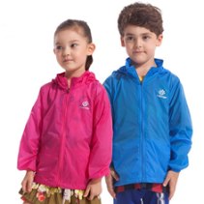

Friday’s Cooking Activity: Measuring, pouring, mixing….. and some spilling took place as we prepared porridge. We will tried to make it not too lumpy (like Daddy Bear’s), not too sweet (like Mommy Bear’s), but just right (like Baby Bear’s)!
The Bear Family was unable to eat their porridge since Goldilocks knocked over the table and spilled it as she ran from their cottage. Instead, they ate toast. So, of course we also made teddy bear toast!
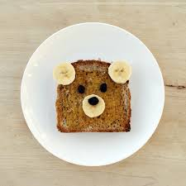

Fairy Tale Problem STEM Activity
Since Goldilocks broke Baby Bear’s Chair, we needed to help make a new one. This time the bears wanted a family chair. It needs to be strong enough to hold each one of them! We used picture cards that modeled the construction pieces and how to build a chair. Students had the time and opportunity to explore and fail on their own. This is part of the learning process. They are learning it is okay if they aren’t successful on the first try – or even the second or third. Wobbly chairs and giggles were part of the process!

Dates You Need To Know
Winter Break Dec. 22 – Jan. 2, 2017
Student Holiday Jan. 3, 4, 2017
Students Return Jan. 5, 2017

